Angola

## GNI per capita and development level

The data set shows the GNI per capita and development level of the country each year.

## # A tibble: 19 x 5  
## country iso3c date GNIperCapita devCategory   
## <chr> <chr> <dbl> <dbl> <chr>   
## 1 Angola AGO 1996 2321. Lower Middle Income  
## 2 Angola AGO 1998 2321. Lower Middle Income  
## 3 Angola AGO 2000 1731. Lower Middle Income  
## 4 Angola AGO 2002 2186. Lower Middle Income  
## 5 Angola AGO 2003 2197. Lower Middle Income  
## 6 Angola AGO 2004 2312. Lower Middle Income  
## 7 Angola AGO 2005 2528. Lower Middle Income  
## 8 Angola AGO 2006 2660. Lower Middle Income  
## 9 Angola AGO 2007 2982. Lower Middle Income  
## 10 Angola AGO 2008 3044. Lower Middle Income  
## 11 Angola AGO 2009 3283. Lower Middle Income  
## 12 Angola AGO 2010 3242. Lower Middle Income  
## 13 Angola AGO 2011 3229. Lower Middle Income  
## 14 Angola AGO 2012 3415. Lower Middle Income  
## 15 Angola AGO 2013 3507. Lower Middle Income  
## 16 Angola AGO 2014 3613. Lower Middle Income  
## 17 Angola AGO 2015 3589. Lower Middle Income  
## 18 Angola AGO 2016 3372. Lower Middle Income  
## 19 Angola AGO 2017 3218. Lower Middle Income

## GDP growth and economic growth classification

The data set shows the GDP growth and the ecomic growth classification of the country each year.

## # A tibble: 19 x 5  
## country iso3c date GDPannualGrowthRate GDPgrowthCategory4  
## <chr> <chr> <dbl> <dbl> <fct>   
## 1 Angola AGO 1996 13.5 fast growth   
## 2 Angola AGO 1998 4.69 moderate growth   
## 3 Angola AGO 2000 3.05 moderate growth   
## 4 Angola AGO 2002 13.7 fast growth   
## 5 Angola AGO 2003 2.99 moderate growth   
## 6 Angola AGO 2004 11.0 fast growth   
## 7 Angola AGO 2005 15.0 fast growth   
## 8 Angola AGO 2006 11.5 fast growth   
## 9 Angola AGO 2007 14.0 fast growth   
## 10 Angola AGO 2008 11.2 fast growth   
## 11 Angola AGO 2009 0.859 slow growth   
## 12 Angola AGO 2010 4.40 moderate growth   
## 13 Angola AGO 2011 3.47 moderate growth   
## 14 Angola AGO 2012 8.54 fast growth   
## 15 Angola AGO 2013 4.95 moderate growth   
## 16 Angola AGO 2014 4.82 moderate growth   
## 17 Angola AGO 2015 0.944 slow growth   
## 18 Angola AGO 2016 -2.58 negative grwoth   
## 19 Angola AGO 2017 -0.147 negative grwoth

## Development trend

The plot shows the development trend of the country.

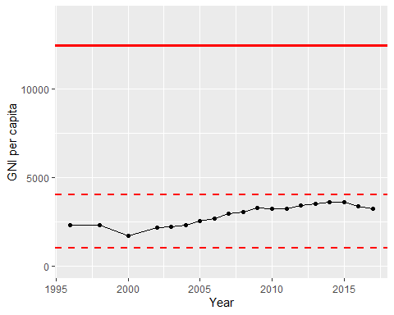

GNI Per Capita Trend